TATA MEMORIAL CENTRE
TATA MEMORIAL HOSPITAL
(A Grant-in Aid Institute under Dept. of Atomic Energy, Govt. of India)
DR. E. BORGES MARG,
PAREL, MUMBAI 400 012

c
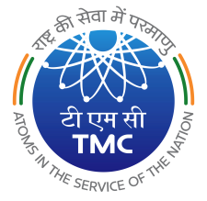
20/03/2023
GeM Tender Notice No 52
Sub: Please visit GeM website www.gem.gov.in for following tenders:

Sr. No. | Description of the item | Qty. | GeM Bid No. | Pre bid date and Time | Bid End Date and Time | Bid Opening date & Time
1 | Cystoscopy Cart (Urology), TMH | 01 No | GEM/2023/B/3281150 | 28/03/2023 at 2.00 pm in Tata Memorial Hospital Service Block, 4th Floor, Conference room | 05.05.2023 upto 11.00 a.m | 05.05.2023 from 11.30 a.m onwards
2 | Table Top Sterilizer, TMH | 01 No | GEM/2023/B/3274126 | NA | 06.04.2023 upto 5.00pm | 06.04.2023 form 5.30 pm

PURCHASE OFFICER

